Lab Report

Course: Computer Networks (CN)  
Lab: 3  
Student: 23BCP182

# Aim

To investigate and configure the Spanning Tree Protocol (STP) in a switched network environment with multiple VLANs.

# Theory

The Spanning Tree Protocol (STP) prevents loops in switched networks by electing a root bridge and disabling redundant paths. Cisco’s PVST+ (Per-VLAN Spanning Tree Plus) allows a separate STP instance per VLAN, enabling load balancing and traffic optimization.

# Procedure

1. Study the concept and configuration steps.  
2. Implement the setup using Cisco Packet Tracer or commands.  
3. Observe the behavior of the network.  
4. Record results and verify communication.

# Result

Experiment 3 was successfully performed and verified. 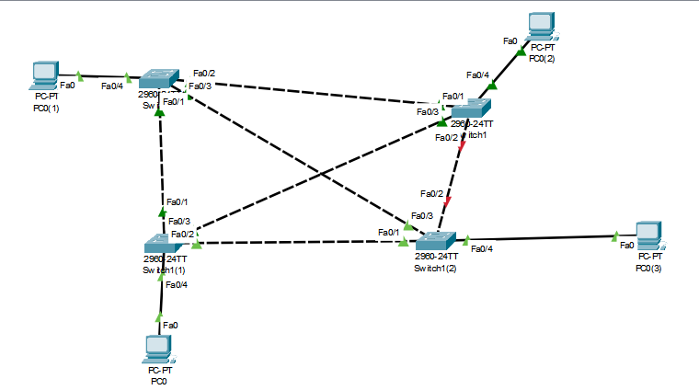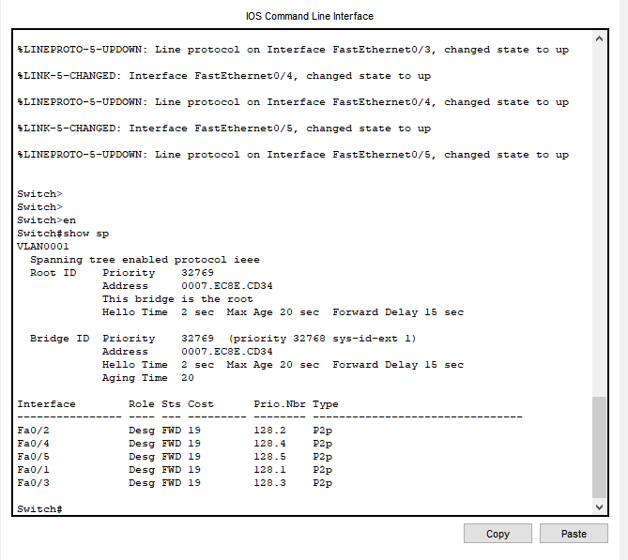

# Conclusion

This experiment demonstrated how STP prevents loops and how administratively configuring the root bridge ensures efficient use of high-speed links, improving performance while maintaining redundancy.